Lab-08 Tasks

Task-01:
class Vehicle { //Base Class
protected int vehicleID;
protected String brand;
protected int speed;
protected String fuelType;

public Vehicle(int vehicleID, String brand, int speed, String fuelType) {
this.vehicleID = vehicleID;
this.brand = brand;
this.speed = speed;
this.fuelType = fuelType;
}

//Functions
public void start(){
System.out.println("Vehicle has started.");
}

public void stop(){
System.out.println("Vehicle has stopped.");
}

public void displayInfo(){
System.out.println("==== Vehicle Information ====");
System.out.println("Vehicle ID : " + vehicleID);
System.out.println("Brand: " + brand);
System.out.println("Speed: " + speed);
System.out.println("Fuel type: " + fuelType);
}
}

class Car extends Vehicle {
private boolean sunroof = false;
private boolean cruiseControl = false;

public Car(int vehicleID, String brand, int speed, String fuelType){
super(vehicleID, brand, speed, fuelType);
}

public void openSunroof(){
if(!sunroof){
sunroof = true;
System.out.println("Sunroof opened.");
}
else{
System.out.println("Sunroof already opened.");
}
}

public void activateCruiseControl(){
if(!cruiseControl){
cruiseControl = true;
System.out.println("Cruise control activated.");
}
else{
System.out.println("Cruise control is already activated.");
}
}
}

class Truck extends Vehicle {
private int weight = 0; //assume initial weight is zero

public Truck(int vehicleID, String brand, int speed, String fuelType) {
super(vehicleID, brand, speed, fuelType);
}

public void loadCargo(int weight){
this.weight = weight;
System.out.println("Weight loaded.");
}

public void unloadCargo(){
weight = 0;
System.out.println("Weight unloaded.");
}
}

class Motorbike extends Vehicle {
private boolean wheelie = false;
private boolean ABS = false;

public Motorbike(int vehicleID, String brand, int speed, String fuelType) {
super(vehicleID, brand, speed, fuelType);
}

public void popWheelie(){
if(!wheelie){
wheelie = true;
System.out.println("Popping a wheelie.");
}
else{
System.out.println("Already on one wheel.");
}
}

public void enableABS(){
if(!ABS){
ABS = true;
System.out.println("ABS enabled.");
}
else{
System.out.println("ABS already enabled.");
}
}
}

class Bus extends Vehicle {
private int passengers = 0;

public Bus(int vehicleID, String brand, int speed, String fuelType) {
super(vehicleID, brand, speed, fuelType);
}

public void pickPassengers(int count){
passengers += count;
System.out.println("No. of passengers picked: " + passengers);
}

public void dropPassengers(){
passengers = 0;
System.out.println("Passengers dropped.");
}
}

class task1 {
public static void main(String[] args) {
//Child class objects
Car car = new Car(123, "Toyota", 180, "Petrol");
Truck truck = new Truck(456, "Volvo", 150, "Diesel");
Motorbike motorbike = new Motorbike(107, "Yamaha", 180, "Petrol");
Bus bus = new Bus(204, "Hino", 220, "Electric");

car.start();
car.displayInfo();
car.openSunroof();
car.activateCruiseControl();
class Vehicle { //Base Class
protected int vehicleID;
protected String brand;
protected int speed;
protected String fuelType;

public Vehicle(int vehicleID, String brand, int speed, String fuelType) {
this.vehicleID = vehicleID;
this.brand = brand;
this.speed = speed;
this.fuelType = fuelType;
}

//Functions
public void start(){
System.out.println("Vehicle has started.");
}

public void stop(){
System.out.println("Vehicle has stopped.");
}

public void displayInfo(){
System.out.println("==== Vehicle Information ====");
System.out.println("Vehicle ID : " + vehicleID);
System.out.println("Brand: " + brand);
System.out.println("Speed: " + speed);
System.out.println("Fuel type: " + fuelType);
}
}

class Car extends Vehicle {
private boolean sunroof = false;
private boolean cruiseControl = false;

public Car(int vehicleID, String brand, int speed, String fuelType){
super(vehicleID, brand, speed, fuelType);
}

public void openSunroof(){
if(!sunroof){
sunroof = true;
System.out.println("Sunroof opened.");
}
else{
System.out.println("Sunroof already opened.");
}
}

public void activateCruiseControl(){
if(!cruiseControl){
cruiseControl = true;
System.out.println("Cruise control activated.");
}
else{
System.out.println("Cruise control is already activated.");
}
}
}

class Truck extends Vehicle {
private int weight = 0; //assume initial weight is zero

public Truck(int vehicleID, String brand, int speed, String fuelType) {
super(vehicleID, brand, speed, fuelType);
}

public void loadCargo(int weight){
this.weight = weight;
System.out.println("Weight loaded.");
}

public void unloadCargo(){
weight = 0;
System.out.println("Weight unloaded.");
}
}

class Motorbike extends Vehicle {
private boolean wheelie = false;
private boolean ABS = false;

public Motorbike(int vehicleID, String brand, int speed, String fuelType) {
super(vehicleID, brand, speed, fuelType);
}

public void popWheelie(){
if(!wheelie){
wheelie = true;
System.out.println("Popping a wheelie.");
}
else{
System.out.println("Already on one wheel.");
}
}

public void enableABS(){
if(!ABS){
ABS = true;
System.out.println("ABS enabled.");
}
else{
System.out.println("ABS already enabled.");
}
}
}

class Bus extends Vehicle {
private int passengers = 0;

public Bus(int vehicleID, String brand, int speed, String fuelType) {
super(vehicleID, brand, speed, fuelType);
}

public void pickPassengers(int count){
passengers += count;
System.out.println("No. of passengers picked: " + passengers);
}

public void dropPassengers(){
passengers = 0;
System.out.println("Passengers dropped.");
}
}

class task1 {
public static void main(String[] args) {
//Child class objects
Car car = new Car(123, "Toyota", 180, "Petrol");
Truck truck = new Truck(456, "Volvo", 150, "Diesel");
Motorbike motorbike = new Motorbike(107, "Yamaha", 180, "Petrol");
Bus bus = new Bus(204, "Hino", 220, "Electric");

car.start();
car.displayInfo();
car.openSunroof();
car.activateCruiseControl();

truck.start();
truck.displayInfo();
truck.loadCargo(200);
truck.unloadCargo();

motorbike.start();
motorbike.displayInfo();
motorbike.popWheelie();
motorbike.enableABS();

bus.start();
bus.displayInfo();
bus.pickPassengers(5);
bus.dropPassengers();
}
}

truck.start();
truck.displayInfo();
truck.loadCargo(200);
truck.unloadCargo();

motorbike.start();
motorbike.displayInfo();
motorbike.popWheelie();
motorbike.enableABS();

bus.start();
bus.displayInfo();
bus.pickPassengers(5);
bus.dropPassengers();
}
}
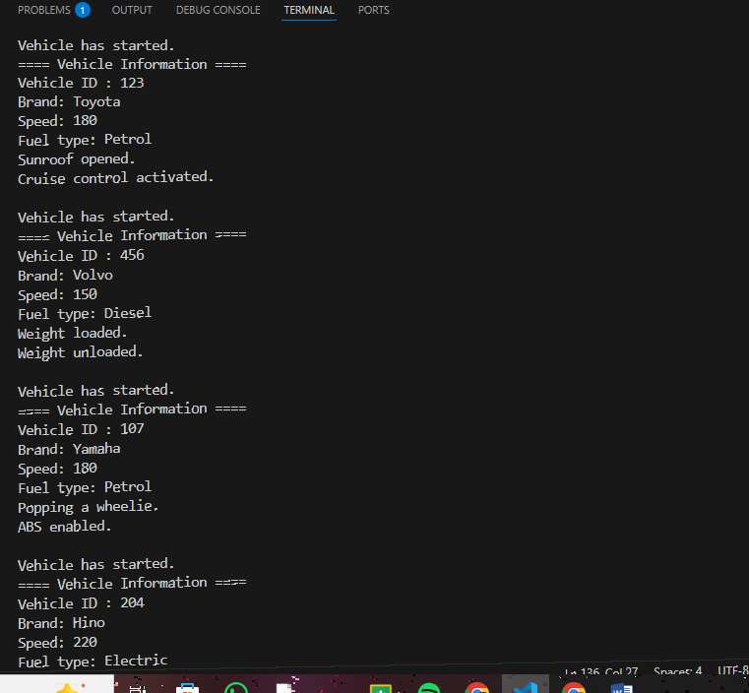
Output:

Task-02:
interface Communication {
void connect(String network); //Wifi or LAN
}

interface PowerManagement {
//boolean powerStatus = false;
//int batteryStatus = 54;
void powerOn();
void powerOff();
int checkBattery();
}

class Printer implements Communication, PowerManagement {
boolean powerStatus = false;
int batteryStatus = 54;

public void connect(String network){
System.out.println("Printer connected to network: " + network);
}

public void powerOn(){
if(!powerStatus){
powerStatus = true;
System.out.println("Printer powered on.");
}
else{
System.out.println("Printer already powered on.");
}
}

public void powerOff(){
if(powerStatus){
powerStatus = false;
System.out.println("Printer powered off.");
}
else{
System.out.println("Printer already powered off.");
}
}

public int checkBattery(){
return batteryStatus;
}
}

class Scanner implements Communication, PowerManagement {
boolean powerStatus = false;
int batteryStatus = 70;

public void connect(String network){
System.out.println("Scanner connected to network: " + network);
}

public void powerOn(){
if(!powerStatus){
powerStatus = true;
System.out.println("Scanner powered on.");
}
else{
System.out.println("Scanner already powered on.");
}
}

public void powerOff(){
if(powerStatus){
powerStatus = false;
System.out.println("Scanner powered off.");
}
else{
System.out.println("Scanner already powered off.");
}
}

public int checkBattery(){
return batteryStatus;
}
}
public class task2 {
public static void main(String[] args) {
Printer printer = new Printer();
Scanner scanner = new Scanner();
interface Communication {
void connect(String network); //Wifi or LAN
}

interface PowerManagement {
//boolean powerStatus = false;
//int batteryStatus = 54;
void powerOn();
void powerOff();
int checkBattery();
}

class Printer implements Communication, PowerManagement {
boolean powerStatus = false;
int batteryStatus = 54;

public void connect(String network){
System.out.println("Printer connected to network: " + network);
}

public void powerOn(){
if(!powerStatus){
powerStatus = true;
System.out.println("Printer powered on.");
}
else{
System.out.println("Printer already powered on.");
}
}

public void powerOff(){
if(powerStatus){
powerStatus = false;
System.out.println("Printer powered off.");
}
else{
System.out.println("Printer already powered off.");
}
}

public int checkBattery(){
return batteryStatus;
}
}

class Scanner implements Communication, PowerManagement {
boolean powerStatus = false;
int batteryStatus = 70;

public void connect(String network){
System.out.println("Scanner connected to network: " + network);
}

public void powerOn(){
if(!powerStatus){
powerStatus = true;
System.out.println("Scanner powered on.");
}
else{
System.out.println("Scanner already powered on.");
}
}

public void powerOff(){
if(powerStatus){
powerStatus = false;
System.out.println("Scanner powered off.");
}
else{
System.out.println("Scanner already powered off.");
}
}

public int checkBattery(){
return batteryStatus;
}
}
public class task2 {
public static void main(String[] args) {
Printer printer = new Printer();
Scanner scanner = new Scanner();

printer.connect("Wi-fi");
printer.powerOn();
System.out.println("Battery level: " + printer.checkBattery());
printer.powerOff();

System.out.println("");

scanner.connect("Wi-fi");
scanner.powerOn();
System.out.println("Battery level: " + scanner.checkBattery());
scanner.powerOff();
}
}

printer.connect("Wi-fi");
printer.powerOn();
System.out.println("Battery level: " + printer.checkBattery());
printer.powerOff();

System.out.println("");

scanner.connect("Wi-fi");
scanner.powerOn();
System.out.println("Battery level: " + scanner.checkBattery());
scanner.powerOff();
}
}

Output:

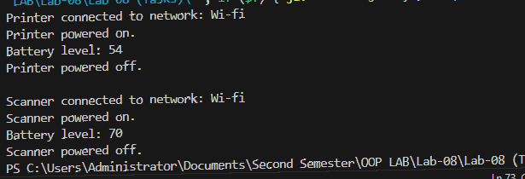
Task-03:
interface Teaching {
public void conductLecture();
}

interface Research {
public void publishPaper();
}

class Staff {
private String name;
private int id;
private String department;

public Staff(String name, int id, String department){
this.name = name;
this.id = id;
this.department = department;
}

public void displayInfo(){
System.out.println("==== Staff Information ====");
System.out.println("Name: " + name);
System.out.println("ID: " + id);
System.out.println("Department: " + department);
}
}

class Professor extends Staff implements Teaching, Research {

public Professor(String name, int id, String department){
super(name, id, department);
}

public void conductLecture(){
System.out.println("Conducting lecture.");
}

public void publishPaper(){
System.out.println("Publishing research paper.");
}
}

class LabInstructor extends Staff implements Teaching {

public LabInstructor(String name, int id, String department){
super(name, id, department);
}

public void conductLecture(){
System.out.println("Conducting lecture.");
}

// public void publishPaper(){ System.out.println("Not allowed!"); }
}

class ResearchAssistant extends Staff implements Research{

public ResearchAssistant(String name, int id, String department){
super(name, id, department);
}

// public void conductLecture(){ System.out.println("Not allowed!");}

public void publishPaper(){
System.out.println("Publishing research paper.");
}
}

public class task3 {
public static void main(String[] args) {
Professor professor = new Professor("Shayan", 123, "Black-ops");
LabInstructor labInstructor = new LabInstructor("Musa", 321, "Virtual Reality");
ResearchAssistant researchAssistant = new ResearchAssistant("Sherry", 456, "Programming");

professor.conductLecture();
professor.publishPaper();
professor.displayInfo();

labInstructor.con interface Teaching {
public void conductLecture();
}

interface Research {
public void publishPaper();
}

class Staff {
private String name;
private int id;
private String department;

public Staff(String name, int id, String department){
this.name = name;
this.id = id;
this.department = department;
}

public void displayInfo(){
System.out.println("==== Staff Information ====");
System.out.println("Name: " + name);
System.out.println("ID: " + id);
System.out.println("Department: " + department);
}
}

class Professor extends Staff implements Teaching, Research {

public Professor(String name, int id, String department){
super(name, id, department);
}

public void conductLecture(){
System.out.println("Conducting lecture.");
}

public void publishPaper(){
System.out.println("Publishing research paper.");
}
}

class LabInstructor extends Staff implements Teaching {

public LabInstructor(String name, int id, String department){
super(name, id, department);
}

public void conductLecture(){
System.out.println("Conducting lecture.");
}

// public void publishPaper(){ System.out.println("Not allowed!"); }
}

class ResearchAssistant extends Staff implements Research{

public ResearchAssistant(String name, int id, String department){
super(name, id, department);
}

// public void conductLecture(){ System.out.println("Not allowed!");}

public void publishPaper(){
System.out.println("Publishing research paper.");
}
}

public class task3 {
public static void main(String[] args) {
Professor professor = new Professor("Shayan", 123, "Black-ops");
LabInstructor labInstructor = new LabInstructor("Musa", 321, "Virtual Reality");
ResearchAssistant researchAssistant = new ResearchAssistant("Sherry", 456, "Programming");

professor.conductLecture();
professor.publishPaper();
professor.displayInfo();

labInstructor.conductLecture();
labInstructor.displayInfo();

researchAssistant.publishPaper();
researchAssistant.displayInfo();
}
}

ductLecture();
labInstructor.displayInfo();

researchAssistant.publishPaper();
researchAssistant.displayInfo();
}
}

Output:
